**Steps for Custom Tag in Django**

1) In your app create a python package and name it as "templatetags".

2) Create a new python file in "templatetags" package and name it.

**Example :**

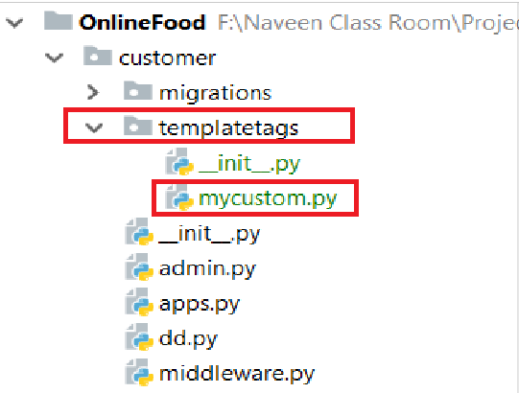

3) Write the Program into **"mycustom.py"** file.

**from** django **import** template  
  
register = template.Library()  
  
@register.simple_tag()  
**def** totalAmount(quantity,price):  
 **return** price*quantity

**Note:** variable name must be **"register"** only.

4) In **"settings.py"** file go to **"TEMPLATES"** list and add a library

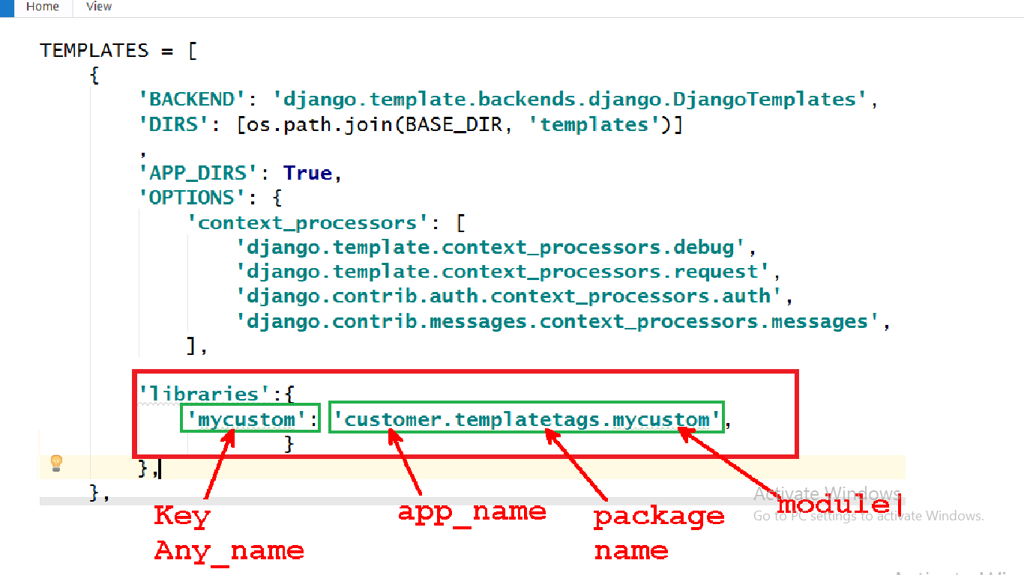

5) In template "load" custom tag.

Example :

{% **load mycustom** %} ---- Key

6) Use the function name as a tag name

Example

{% **totalAmount x**.**quantity x**.**food**.**price** %}

7) after doing the changes rebuild the server.